**DAILY ONLINE ACTIVITIES SUMMARY**

|  |  |  |  |  |  |  |  |  |
| --- | --- | --- | --- | --- | --- | --- | --- | --- |
| **Date:** | **10/06/2020** | | | | | **Name:** | **PRANEETA P HANDRAL** | |
| **Sem & Sec** | **4thSEM. & ‘B’ SEC.** | | | | | **USN:** | **4AL19CS401** | |
| **Online Test Summary** | | | | | | | | |
| **Subject** | | **OBJECT ORIENTED CONCEPTS** | | | | | | |
| **Max. Marks** | | **30** | | **Score** | | | **16** | |
| **Certification Course Summary** | | | | | | | | |
| **Course** | **Introduction to Cyber security** | | | | | | | |
| **Certificate Provider** | | | **Greatlearning Academy** | | **Duration** | | | **5 Hrs.** |
| **Coding Challenges** | | | | | | | | |
| **Problem Statement:** Java Program to find the longest repeating sequence in a string | | | | | | | | |
| **Status: Executed.** | | | | | | | | |
| **Uploaded the report in Github** | | | | | **Yes** | | | |
| **If yes Repository name** | | | | | **LockdownCoding**  <https://github.com/praneetahandral/lockdowncoding> | | | |
| **Uploaded the report in slack** | | | | | **Yes** | | | |

**Online Test Summary:​** **18CS45 online test was scheduled from 9:15 am t0 9:40 am** . **The portion for the IA was 3rd and 4th module there were 15 questions and the time assigned was 30 minutes the questions were mcq type. There were 15 questions of 2 marks respectively.**

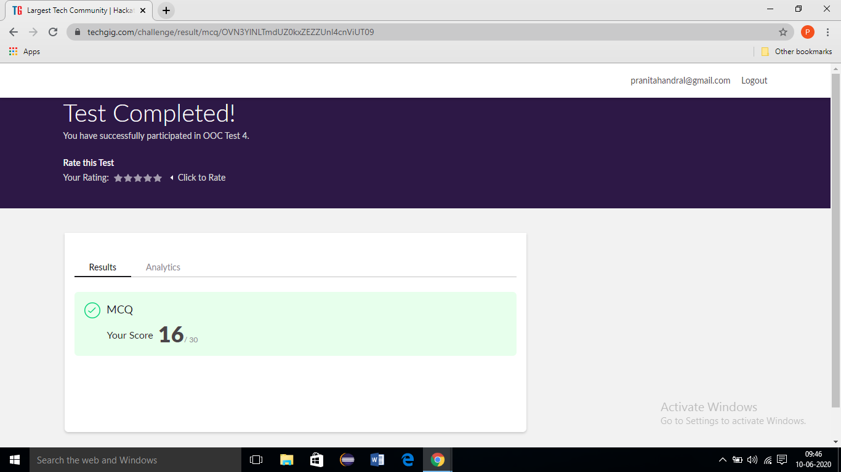

**Online Certification Course Summary**: I have taken my Online Certification Course in **Great learning academy** the course which I have opted is **Introduction to Cyber security**. Course contains videos, tutorials, assessments and quiz. Today I have learn about **Secure System Design** and **Introduction to Cryptography** and **Threats and Vulnerabilities.**

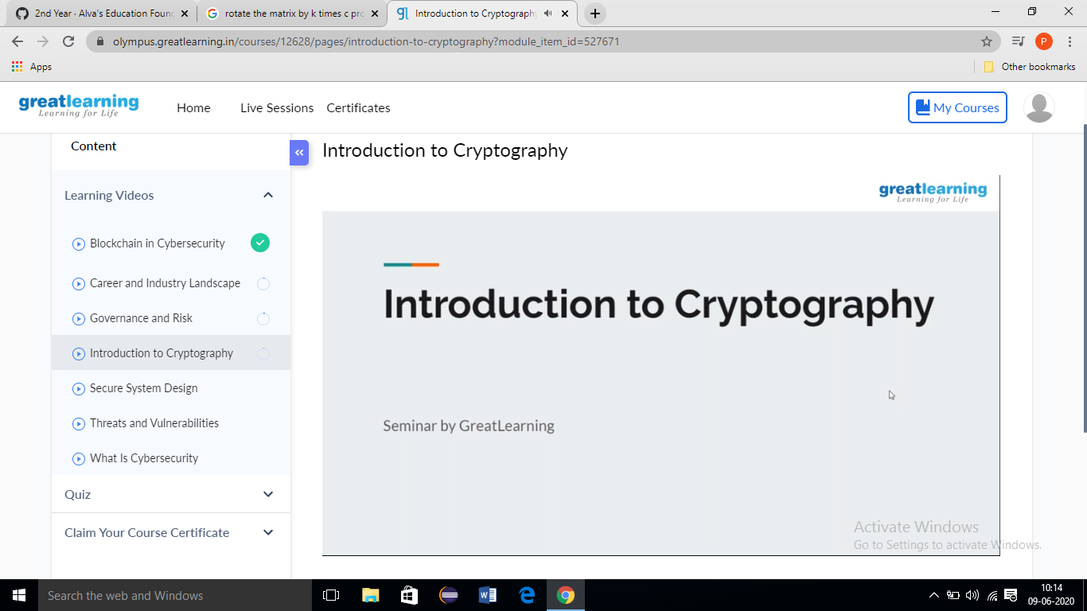

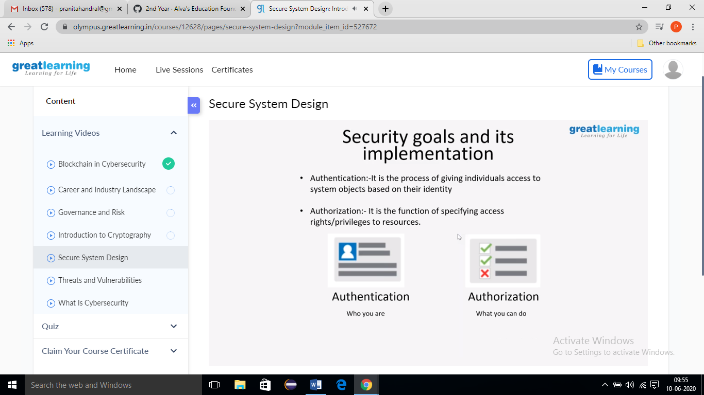

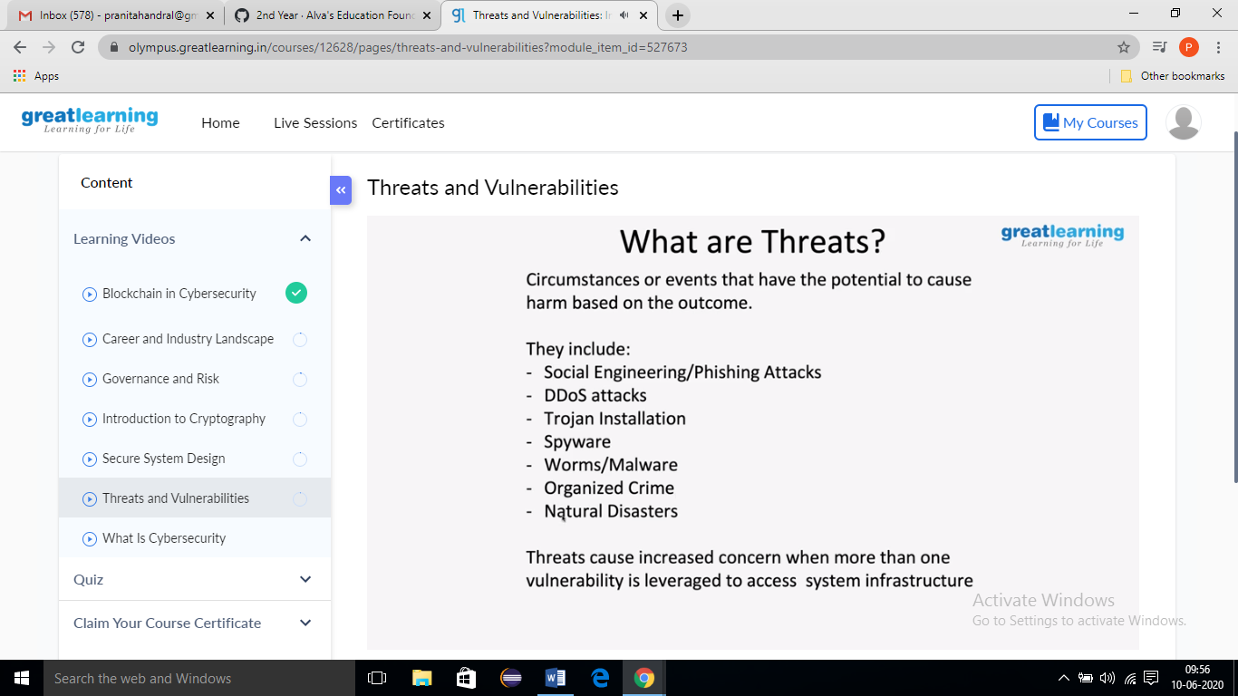

**Online Coding Summary: Today I received one program from Prof.** **Reena** **CSE Dept. The program is mentioned above. to my GitHub repository and I’ve shared the snapshot below.**

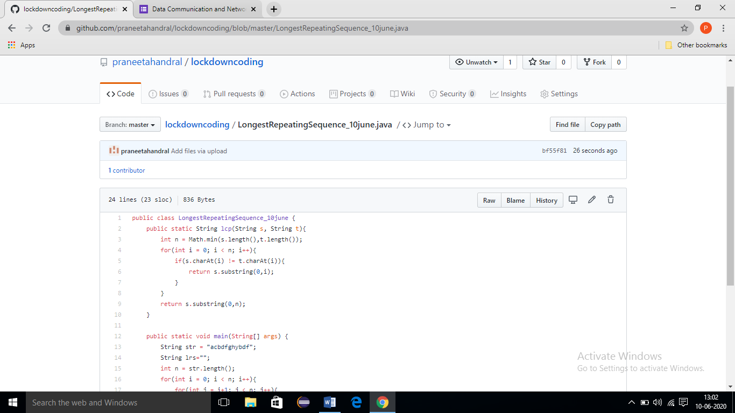

c